**Drawing for Haversack Bag**

Handle

Side Pocket (12"Χ9")

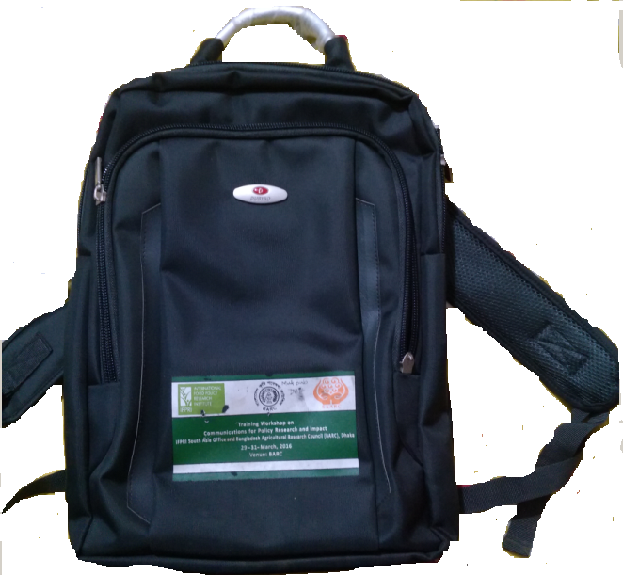

Height 17"

Breadth- 12.5"

Width- 3.5"

Shoulder Belt

**Front Side**

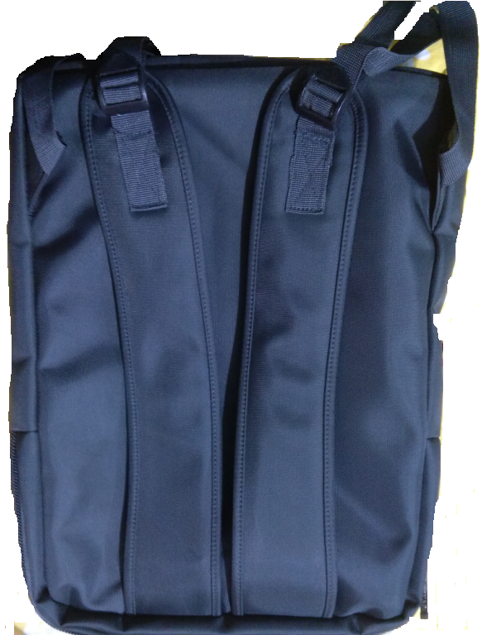

**Back Side**

